A Measurement of the Muon Half-Life
Using
CHICOS Particle Detector Equipment
and
Analysis Methods Accessible
at the High School Level

Bob Gates
Jim Hill
Theresa Lynn
Bob McKeown
Rudy Resch
Anne Sullivan
Trung Tran

California HIgh school Cosmic ray ObServatory (CHICOS)

2006


In this lab unit, student groups explore the concepts involved in the radioactive decay of an elementary particle called the muon, and then obtain their own experimental values of the muon’s half-life using data collected by CHICOS particle detector equipment.

Relevant topics in physics and mathematics are covered through reading and lecture notes, interspersed with simple (and ultra-low-budget) hands-on activities to illustrate the phenomena involved. All materials are accessible without a calculus background; previous exposure to logarithms in an algebra course is helpful, but logarithms are reviewed. The science presented here should be accessible to all students at the high school level, though students with no previous high school physical science course may have trouble placing the current material in a familiar context.

Once they have completed the preparatory lessons and activities, students should understand the basic concepts of radioactive decay and particle half-life. They should be familiar with the analysis tools (histograms, logarithms, and linear “best-fit” or regression lines) required to determine a half-life from a collection of observed particle decay times. At this point, students collect data on the decay times of actual muons and enter this data into a pre-set Excel worksheet to determine the muon half-life. The data can be obtained on-site in the Kellogg Lab at Caltech, or downloaded from the CHICOS website. Either method ensures students a unique, current data set of muon decay times recorded “live” on the equipment in Kellogg at the time when students are performing their experiment.

The muon half-life lab unit was initially developed as a two-day (12-hour) workshop for teacher/student groups in the CHICOS summer program, 2006. Within a traditional school schedule, it may be completed in either one or two weeks of class time, depending on students’ math/science backgrounds and the amount of time that must be spent on the preparatory lessons.

The muon lifetime measurement relates to many CA state science standards, including:
- Physics (conservation of energy and momentum, inelastic collisions, electric charge)
- Chemistry (atomic and nuclear structure, E=mc², radioactive decay and half-life, conservation of charge)
- Investigation and Experimentation (statistical variability and need for repeated/accumulated measurements, use of spreadsheets to collect and analyze data, synthesis/application of concepts from several areas of science, use of mathematical tools to describe patterns in scientific data, importance of knowing realistic experimental uncertainty)
- Mathematics (exponential decay, logarithms, algebra, histograms, graphing data and fitting regression lines)

Introduction to Radioactive Decay and Half-Life: ¹⁴C Dating

(ACTIVITY: Bean Archaeology)

Half-Life and How to Measure It

(ACTIVITY: Twizzler Graph)

What is a Muon?

Random Nature of Individual Muon Decays

(ACTIVITY: The Coin Toss)

Description of the Caltech Muon Lifetime Apparatus

Data Collection and Analysis in Excel

***Download live data from http://www.chicos.caltech.edu/internal/muondata/
Introduction to Radioactive Decay and Half-Life: ¹⁴C Dating

Archaeologists determine the approximate ages of many artifacts by a method called carbon-14 (¹⁴C) dating. You may have heard of ¹⁴C dating for such objects as the Dead Sea Scrolls, the Shroud of Turin, or prehistoric human remains. How does it work? 
A portion of the Dead Sea Scrolls. Since paper and other plant-based writing surfaces are generally new when written on, Carbon-14 dating can help determine the ages of ancient documents.

Many chemical elements exist in several different forms, called isotopes, which differ from each other only in their number of neutrons per atom. Since chemical reactions are governed by the exchange of electrons between atoms, different isotopes of the same element are identical in their chemical behavior and participate equally well in any chemical reactions that are taking place.
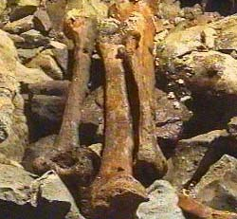
The most stable and by far the most common isotope of carbon, ¹²C, has six protons and six neutrons in the nucleus of each carbon atom. However, there is a small natural abundance of the heavier isotope ¹⁴C, with two extra neutrons per atom… and ¹⁴C decays radioactively with a half-life of about 5,700 years. New materials incorporate ¹⁴C through its natural abundance on Earth, but once an object is made, new carbon does not get incorporated… and the old ¹⁴C begins to radioactively decay over thousands of years until less and less of it is present in an ancient scroll, cloth, or bone fragment. By measuring what fraction of an object’s carbon is actually ¹⁴C today, scientists can tell how long it has been since the object was new.
Bones and fossils can be dated by Carbon-14 content.

Let’s go into a little more detail on the subject of ¹⁴C. First of all, if ¹⁴C is radioactive and unstable, why is there a natural abundance of ¹⁴C on Earth? Why isn’t it all long gone? Well, it turns out that ¹⁴C is constantly being made when cosmic ray particles interact with nuclei in the air via a process that looks like this:
p + (atomic nucleus in the air) → n + (junk)
n + ¹⁴N → ¹⁴C + (junk).
The (junk) produced in the scattering events above is actually quite interesting and important for various other scientific purposes, but it does not come into the story of ¹⁴C. The important thing is that cosmic ray particles, which have been around throughout Earth’s history, have always been interacting with nuclei in the air and providing Earth with a fairly constant level of ¹⁴C in the air, where it is formed into ordinary (but ever so slightly heavier) molecules of carbon dioxide (CO₂). CO₂ is dissolved in water; it is incorporated into plant material through photosynthesis,
nCO₂ + nH₂O + energy → (CH₂O)_{n} + nO₂
and, to make a long story short, the ¹⁴C in its natural abundance is locked into tree rings, paper, animal bones, cloth fibers, and many other materials when they are brand-new.
Now, as an object ages, the chemistry of creating carbon-rich organic molecules is over and the small fraction of radioactive ¹⁴C in the object is no longer being replenished by growth and incorporation of new ¹⁴C from the atmosphere. The existing ¹⁴C, though it is locked in chemically, still decays radioactively because radioactive decay is a nuclear process, not a chemical one:
¹⁴C → ¹⁴N + e⁻ + ν_{e}
(¹⁴C → ¹⁴N + electron + electron antineutrino).
Notice ¹⁴C has (Z=6, N=8) and ¹⁴N has (Z=7, N=7), so in many ways the decay boils down to:
n → p + e⁻ + ν_{e}
or, if you are familiar with the quark structure of neutrons and protons,
d → u + e⁻ + ν_{e}.
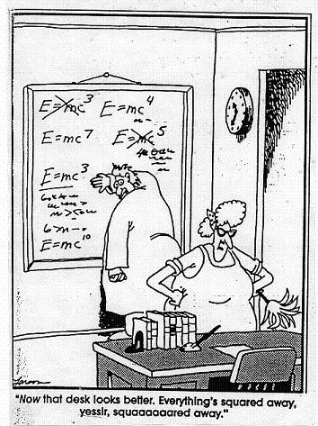
Notice that the radioactive decay conserves electric charge (the electron antineutrino is a neutral particle). It does not conserve the number of atoms of each element, as a chemical reaction would. In fact, it destroys elementary particles and creates others. In the decay reaction above, the d (down quark) is not “made of” an up quark (u), an electron, and an antineutrino; the decay is not simply the separation of component pieces that were already there to begin with. Some particles are destroyed, and brand-new ones are created. There are several conservation rules that do hold, but conservation of electric charge is the only one tied to a property “ordinary” enough to appear in chemistry or in the experience of most non-physicists.
The radioactive decay process does conserve energy, but only if we are allowed to count mass as a type of energy and convert some of the original mass into other forms of energy according to the famous equation E=mc². Even if the original ¹⁴C is at rest, the particles produced in the decay can fly off with nonzero kinetic energy. This conversion back and forth between mass energy and other forms of energy is what nuclear reactions are all about.

However it happens, we have established that the ¹⁴C in an artifact decays over time into ¹⁴N. Each individual ¹⁴C nucleus decays at a time we cannot predict, but if we have many nuclei (as in any macroscopic object), we can talk about the radioactive half-life of about 5,700 years. This is the time it takes for half of the existing ¹⁴C to decay. Thus an object with half the natural amount of ¹⁴C has been around for one half-life and is roughly 5,700 years old. An object with one-quarter the natural amount of ¹⁴C has been through two half-lives, and is therefore about 11,400 years old. Object ages between about 1,000 and several 10,000’s of years can be determined by measuring ¹⁴C abundances in this way.

By telling the story of ¹⁴C dating here, we have explored the phenomenon of radioactive decay and of nuclear interactions in general. We have also introduced the concept of the half-life for an unstable nucleus or other radioactive particle. These concepts will be necessary for an understanding of muons and their decay.
ACTIVITY: Bean Archaeology

(Note: This could also be done with other objects, as long as there is a contrast in color)

Materials: 200 red beans, 200 white beans
(more if you are running multiple copies of the activity at once)

In this exercise, we will imagine that white beans are radioactive, with a half-life of 100 years. We’ll make the (unrealistic) assumption that they simply disappear when they decay. We will also assume that the beans are initially created with a 1:1 ratio of red to white – that is, equal numbers of the two colors.
The instructor will create “artifacts” of various ages by making piles of beans with different ratios of red to white, as specified below. Groups of students will then take the “artifacts” and determine their (approximate) ages. Students should be told the half-life of white beans (100 years for half to “disappear”) and the initial 1:1 ratio of red to white in new “artifacts.”
Reminder: the white beans do not turn into red beans, just as ¹⁴C does not turn into ¹²C. Real ¹⁴C turns into ¹⁴N, so it “disappears” from the point of view of someone measuring all the Carbon in an artifact. Here we assume the white beans simply disappear completely. Also, beans (like particles) decay only in integer numbers.

The instructor prepares the following “artifacts” (piles of beans):
A: 10 red, 10 white
B: 32 red, 16 white
C: 16 red, 1 white
D: 16 red, 4 white
E: 32 red, 1 white
F: 32 red, 0 white
G: 16 red, 6 white
H: 8 red, 5 white

Student groups examine the piles to determine the ages of these “artifacts.” Extra white beans can be used (but do not have to be) for working backwards in time.

Students should create and complete a table as follows:

Artifact | Red | White | Age
A
...
H

Bean Archaeology: Instructor Notes

The instructor may need to assist students in analyzing artifacts A and B, but students should then attempt to analyze C-H without assistance. Students may choose to “date” the artifacts simply by counting and thinking through the mathematics of radioactive decay. However, it may be helpful to work backwards by using the extra white beans. For instance, in dating artifact B students might use the following process:
→There are now 16 white beans.
→One half-life, or 100 years ago, there were twice as many white beans.
→Add 16 extra white beans to the pile.
→Are there equal numbers of red and white beans now?
→Yes. Therefore the artifact was “new” 100 years ago.
→Artifact B is 100 years old.

A Han Dynasty fabric fragment from China, c.26-240 AD. Fabrics like this come from plant or animal materials and can be dated with Carbon-14.
Dating artifacts A-E should be straightforward. In dating artifact F, students should discover that a small amount of material cannot reliably be dated once it is past a certain age. In dating artifacts G and H, students should begin to contemplate radioactive decay as a continuous process over time, rather than something that takes place discretely at an integer number of half-lives.

If samples F-H are difficult for the students, start asking leading questions, e.g.:
Sample F: Could this artifact be 1000 years old?
501 years old? 200 years old?
Sample G: Is the age between two half-lives? Could the estimate be halfway in between?
Sample H: Is the age below a half-life? Try to get them to estimate.

Answers and Comments:
A: new
B: 100 years old
C: 400 years old
D: 200 years old
E: 500 years old
F: more than 500 years old, but can’t be determined exactly
G: between 100 and 200 years old (best estimate is actually 141 years old)
An estimate of 150 years is also accepted, but will be corrected after later activities in this unit
H: between 0 and. 100 years old (best estimate is actually 68 years old)
An estimate of 75 years should also be accepted, then corrected after later activities in this unit.
Half-Life and How to Measure It

This section expands on the principles of exponential decay and half-life. To present this material to students, we suggest starting with the “Twizzler Graph” activity and then building on the outcome of that activity.

ACTIVITY: Twizzler Graph

Materials: One twizzler (red vine) for each participant.
One sheet of graph paper and one pencil for each participant.

Have each student take a twizzler (red vine) and a piece of graph paper to create a graph with twizzler length on the y axis and time on the x axis. This is called a graph of twizzler length vs. time. Make sure the graph area covers most of the page, or it will not be large enough. We will use the symbol “t_{1/2}” to denote half-life. Label the x axis (time axis) with multiples of t_{1/2} equally spaced along the axis: 0, t_{1/2}, 2t_{1/2}, 3t_{1/2}. 4t_{1/2}, 5t_{1/2}....
Have each student place a twizzler vertically on the graph at time=0 and draw a mark to show the twizzler’s original length. By the definition of a half-life, the twizzler should lose half its length every t_{1/2} of time. Have students tear off and eat half the twizzler to simulate the passage of the first half-life. Then have them place the remaining piece vertically on the graph at time=t_{1/2} and draw a mark to graph the length at this time. Continue the process, having students tear off and eat half of whatever piece they have left at each time increment. Ask students to complete the entire graph if they can, or stop when the twizzler piece becomes too small to deal with accurately.
While making a graph, students should also complete a table containing the graphed data:
# Half Lives | Fraction of original length remaining
0 | 1
1 | 1/2
2 | …
… | …

After students have completed and checked their graphs:
Let the initial size of the twizzler be called N₀. The length of the twizzler after n half-lives (n t_{1/2}’s) can be canned N(n*t_{1/2}). Have students work alone or as a group to find a formula for N(n*t_{1/2}) as a function of N₀ and n.

Twizzler Graph: Instructor Notes

Student graphs should resemble the “Amount Remaining vs. Time” graph on the next page.

Students should eventually be able to agree on the formula
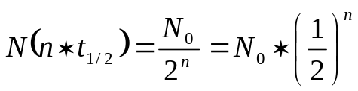
describing the fraction of the twizzler that remains after n half-lives.

The following graph shows an exponential decay of some quantity over time. At time zero, an initial amount N₀ is present in the sample. Solid points show the amount of material remaining after one, two, three, four, or five half-lives. The dotted curve suggests an actual continuous decay over time.

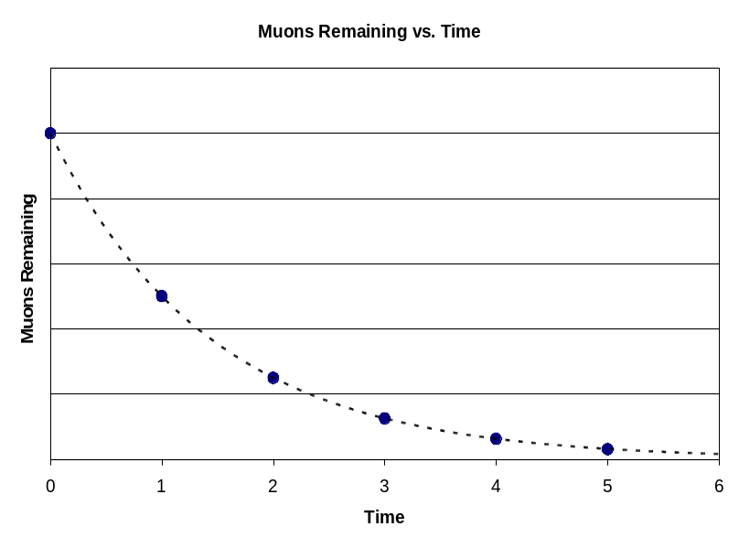
Amount
t_{1/2}
2t_{1/2}
3t_{1/2}
4t_{1/2}
5t_{1/2}
N₀
N₀/2
N₀/4
N₀/8
N₀/16
N₀/32
Amount
N(t)

The amount of material left after N half-lives, N(n*t_{1/2}), can be written
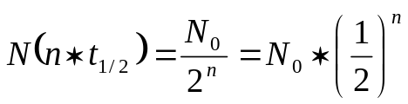. {Equation I}
To find the equation which describes the dotted curve above, we must somehow find a formula N(t) that describes the remaining amount of a radioactive substance after an arbitrary time t rather than an integer number of half-lives (n). In order to generalize Equation I to a formula for N(t), we will first re-express it using the mathematics of logarithms.

Review the definition of a logarithm:
log x = y ↔ x = 10^{y} e.g., log 100 = 2 since 100 = 10².

And review several properties of algebra with logarithms:
log (a/b) = log a – log b since (a/b) = (10^{log a} / 10^{log b}) = 10^{(log a – log b)}
log (c^{d}) = d*(log c) since (c^{d}) = [10^{(log c)}]^{d} = 10^{d*(log c)}.

Now, we go back to Equation I and take the logarithm of both sides to get:
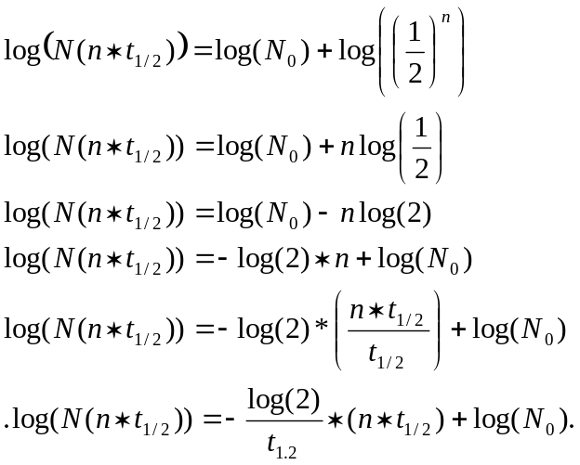

Observe that the final form of the equation above is linear! That is, if we let 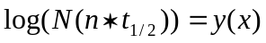 and 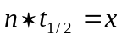, the equation is of the form 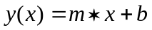.

A graph of this function is sketched below. Notice we have labeled the y-axis 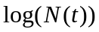, anticipating that we will soon be able to give a function for the dotted line as well as the individual solid points.

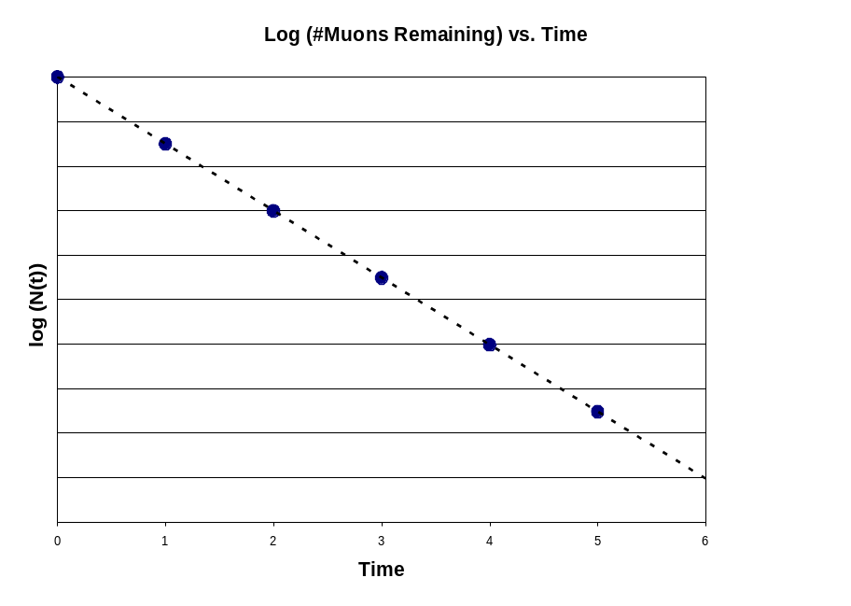
Time
5t_{1/2}
4t_{1/2}
t_{1/2}
2t_{1/2}
3t_{1/2}
0
Amount

But wait! Instead of having and , we can very simply just let 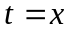 and 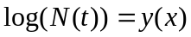. Then we have an equation for the dotted line:

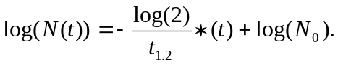 {Equation II}

According to Equation II, 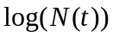 vs. is a straight line with a slope of 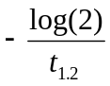.

We can exponentiate (undo the logarithms) to find a formula for N(t), the amount of material left at an arbitrary time:
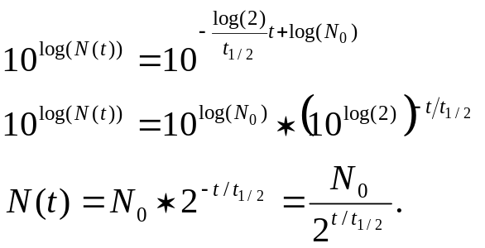 {Equation III}

In practice, physicists graph and analyze exponential decay by using Equation II rather than Equation III. A linear graph is easier to draw and interpret than an exponential decay curve. It is also easier and more reliable to fit a straight line to data than it is to fit a more complicated curve.

What is a Muon?

A muon is a type of subatomic particle. The name is pronounced “myoo-on,” and comes from the Greek letter μ, which we spell “mu” and pronounce “myoo.” A muon is a type of particle very much like an electron. In fact, it is exactly the same as an electron – except heavier. The mass of a muon is 207 times the mass of an electron. You can remember or look up (or take our word for it) that the mass of a proton, by contrast, is about 1,800 times the mass of an electron. So a muon has all the properties of an electron, but is more similar in mass to the big clunkiness (in relative terms) of a proton or other nuclear particle. It’s somewhat hard to imagine the massive muon “dancing” about the nucleus in the mental image we associate with electron clouds in atoms.

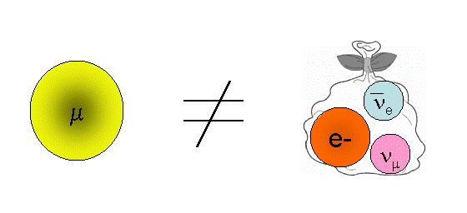
A muon, however, is not made up of any other particles. It is not a bag of electrons or of anything else, but appears to be its own elementary or fundamental particle. It’s just a heavier version of an ordinary electron. If the existence of the muon seems strange and unnecessary to you, you are in good company. The world-famous physicist I. I. Rabi, when first told of the discovery of the muon, said in response, “Who ordered that?”
There’s a good reason why the muon is such an unfamiliar particle: muons are radioactive, and they decay with a half-life of 1.52 microseconds. That’s 1.52 x 10⁻⁶ seconds, or 1.52 millionths of a second. Not 5,700 years, like ¹⁴C, but 1.52 millionths of a second! Muons don’t stick around long enough for anything ordinary to be made out of them. [This may be a good time to review a few units of time we will be using later on. A microsecond is one millionth of a second, which can be written as 0.000001s or 10⁻⁶s. When times get even shorter than this, we turn to the nanosecond, which is one billionth of a second, or 10⁻⁹s. The nanosecond is denoted by “ns.” We use the Greek letter μ as the abbreviation for micro, so “microsecond” is denoted by “μs.” The use of μ as an abbreviation here is not directly related to the fact that μ also forms the symbol and the name for the muon particle we are studying.]
A muon decays into an electron and two neutrinos (the neutrinos are very hard to detect):
μ⁻ → e⁻ + ν_{e} + ν_{μ} (muon → electron + electron antineutrino + muon neutrino)

How and when did scientists first notice such funny, short-lived particles in the first place? The muon was discovered in 1936 by Carl Anderson, a physicist at Caltech. By the way, shortly before this, in 1932-33, Anderson had discovered another unusual particle called the positron. The positron, which is exactly like an electron but with positive instead of negative electric charge, is sometimes called an antielectron and was the first-discovered member of a whole category of particles known as antimatter. Carl Anderson won the Nobel Prize in 1936 for the discovery of antimatter. In fact, he shared that year’s Nobel Prize with Victor Hess, the original discoverer of cosmic rays.
Anderson discovered the existence of positrons and muons by very similar methods. He studied tracks made by various cosmic ray particles in an apparatus called a cloud chamber, under the influence of an applied magnetic field. If you have taken physics and have studied magnetic forces, you will know that a charged particle curves its path when it is influenced by a magnetic field. The direction of the curve tells whether a particle has positive or negative charge, and the radius of curvature tells the charge-to-mass ratio or Z/m for the particle. The muon was discovered when Anderson found particle tracks just like an electron but with Z/m 207 times smaller; the positron was discovered when Anderson found particle tracks just like an electron but curving in the wrong direction.

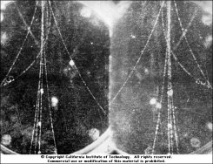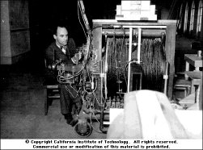
Left: Carl Anderson working on his cloud chamber. Right: A cloud chamber photograph of a cosmic ray min-shower, in which electrons and positrons curve in opposite directions.
The first paper to describe the muon’s radioactive decay was published in the journal Nature in 1940, by a pair of scientists named Williams and Roberts. Very soon after, in 1941, the muon half-life was measured by Rasetti and co-workers and found to be t_{1/2} = 1.5 ± 0.3 μs. We will be measuring the muon half-life in our own experiment. We’ll see if our results match Rasetti’s from 1941!

To make the story just a little bit stranger, fast-forward to 1975. In 1975 scientists discovered a particle exactly like the electron and the muon… only heavier. This extra-heavy electron was called the tau lepton (symbol “τ”, pronounced t-“ow!”). The tau decays to a muon, and has a half-life even shorter than the muon’s. Observations of tau leptons are still rather rare, but stray muons turn out to be so common in cosmic rays that many physicists consider them more of a nuisance than anything else! That’s fortunate for us, as it gives us a free, reliable source of muons for the half-life measurement we will perform.

Random Nature of Individual Muon Decays

We aren’t really going to start with a box of muons and check back every so often to see how many are left; instead we are going to catch cosmic ray muons one by one and record how long each one lasts before decaying. Once we’ve recorded how long each individual muon lasts, we can simply imagine that we started with all of them in a box at time zero. Then we can take a list of times and write down how many of the muons were “still there” at each time.

Another important fact we will discover in measuring real muons is the random nature of radioactive decay. We have been talking so far about a large sample of particles, with half of the particles decaying during each t_{1/2} in time. However, this isn’t exactly how it works. After all, imagine the following conversation between a sample of 16 muons:
“Hey, somebody just put us into a box. We’re supposed to start our radioactive decay thing.”
“OK, OK. Head count! How many of us are there?”
“…12…13…14…15…16 total!”
“What’s 16 divided by 2?”
“That means eight of us will have to decay after the first half-life.”
“Does anybody have a stopwatch?”
“OK, now!! Eight of you drop dead!”

Clearly subatomic particles can’t talk and confer as a group like this. There must be some rule followed by each muon individually that ends up causing half of them to decay after every half-life. Indeed, that is the true situation, as we’ll describe now.
Each individual muon (or other radioactive particle) has a 50% chance of decaying for every half-life it goes through. When we take a large sample of muons, the result of this individual process is that on average the number of muons in the sample goes down by a factor of two for every t_{1/2} in time. It’s only an average, though, and each particle decays (or not) purely by chance. That means there will be some random fluctuation in the number of particles left over time. In some cycles slightly more than half the particles happen to decay; in some cycles, slightly fewer than half decay. The larger the total sample of particles, the less we notice this random fluctuation once we consider the behavior of the entire sample.
This behavior, too, will be simulated in our next activity.

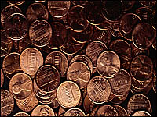



ACTIVITY: The Coin Toss

Materials: There should be at least 4 participants.
Each participant needs 20 pennies, three sheets of graph paper, a pencil, and the two worksheets given below.

Begin with each student working individually to complete the worksheet Individual Coin Toss Results. When each student has completed the 20-coin toss, tabulation, and individual graph, gather the group to compare results and discuss the questions posed on the individual worksheet.

Now pool all participants’ results to complete the worksheet Master Coin Toss Results below. Discuss overall results when students have completed both worksheets. Students should notice that the number of “surviving” pennies does not go down by an exact factor of two for each toss. However, they should notice that the trend is much smoother for a larger data set than for a smaller one.
Worksheet: Individual Coin Toss Results

Begin by taking just your first penny. Toss the penny according to the following rule: if the penny comes up heads, it “survives.” If it comes up tails, it has “decayed.” Toss the first penny until it comes up tails and “decays.” Record the number of tosses needed.
Toss each penny in the same way until it “decays.” Record the number of tosses needed for each one:
Penny Number | Toss Number
 | 1 | 2 | 3 | 4 | 5 | 6 | 7 | 8 | 9
Example | H | H | T
1
2
3
4
5
6
7
8
9
10
11
12
13
14
15
16
17
18
19
20

Now use your results to complete the following table:
Toss Number | #My Pennies Still “Surviving” (number of heads in column for this toss)
1
2
3
4
5
6
7
8

Finally, use your graph paper to create a graph of #My Pennies Surviving vs. #Tosses. Does your graph follow a smooth curve like the sample exponential decay example shown in an earlier section? Do roughly half the pennies “decay” after each toss? How “roughly” is that?
Worksheet: Master Coin Toss Results

#Tosses | #Pennies Still “Surviving” After This Many Tosses:  (PersonA + PersonB + PersonC + …) | #All Pennies Still “Surviving” After This Many Tosses (add up reported numbers from each person recorded in previous column):
1
2
3
4
5
6
7
8

Using a second piece of graph paper, create a graph of #All Pennies Surviving vs. #Tosses, following the data in the master table above.

Does the master graph follow a smooth curve like the sample exponential decay example shown in an earlier section? Do roughly half the pennies “decay” after each toss? How “roughly” is that? Compare the master graph with your individual result graph.

Does the smooth curve of the master graph look like an exponential function? Could it be a 1/x or 1/x² function just as easily? It is hard to tell what function is represented by just looking at a curve like this.

Now calculate the logarithm of the # of pennies surviving at each toss number. Use your third piece of graph paper to plot log(# pennies surviving) vs. tosses, i.e., log(# pennies surviving) on the y-axis and toss number on the x-axis. Draw (by hand) a straight line approximately fitting your data. Find the slope of this line and use it, along with Equation II, to estimate the half-life of a penny (in units of tosses). Your answer should be close to t_{1/2} = 1 toss.

This final method, plotting the logarithm of the amount remaning vs. time, is how we will analyze data to find the muon half-life in our experiment.

Description of the Caltech Muon Lifetime Apparatus

The CHICOS research project has many detectors (nicknamed “shmoos”) designed to measure microscopic cosmic ray particles falling on the surface of the Earth. We mentioned cosmic rays in our discussion of Carbon-14 earlier; a cosmic ray is a subatomic particle from space which hits the Earth while traveling at close to the speed of light. Because a cosmic ray particle traveling that fast has a great deal of kinetic energy, when it hits atoms in the Earth’s atmosphere the impact causes a shower of secondary particles. The shower is large (billions of particles) or small (just one or two particles) depending on the energy of the original or primary cosmic ray from space. Either way, the secondary particles that hit the ground are mostly muons and electrons; they are often called “cosmic rays” just like the primary particles that knocked them loose in the first place. Each CHICOS detector (shmoo) registers around 200 secondary cosmic ray particles every second. Many of these 200 particles per second are muons, so to find the muon half-life we will try to pick out and study the muons which happen to stop and decay while they are inside our detectors.

First we must discuss how a CHICOS shmoo measures cosmic ray particles, both muons and electrons. Then we can understand how to recognize and time a muon decay in the detector.



Figure 1 (below) shows the operation of a regular CHICOS detector, or shmoo. The exterior of a shmoo is a light-tight fiberglass housing; no light from the room or the sun can get inside. Inside, in the bottom of the shmoo, there is a large square, flat piece of plastic (1 meter by 1 meter by 10 cm thick). This is a special type of plastic called a scintillator (the white in the picture). When fast moving charged particles hit the scintillator the incoming particles give some of their energy to the atoms in the scintillator. The atoms in the scintillator don’t want to keep this extra energy so the atoms give off photons. The photons carry away the extra energy from the atoms. These photons are then collected by a photomultiplier tube (PMT) at the top of the shmoo. The PMT turns the photons into an electrical signal or pulse that can be counted by the computer.
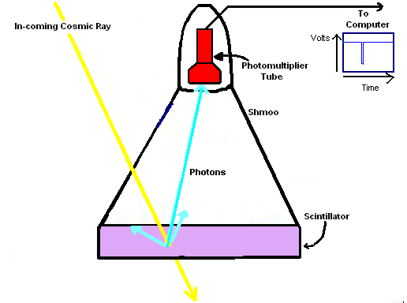
Figure 1

Most cosmic ray particles pass right through the shmoo. Muons that pass right through are very unlikely to decay; this is one of the surprising results of Einstein’s theory of special relativity. However, one or two muons per second are actually slowed and stopped within the thickness of the scintillator. Once a muon has been stopped, the clock is ticking for it to radioactively decay.
A muon decay produces an electron and two neutrinos, as we discussed earlier. An electron produced in a muon decay is known as a Michel electron, even though it is no different from any other electron produced any other way. Even though the original muon was stopped, the radioactive decay converts a lot of the muon’s mass energy to kinetic energy (E=mc² again), so that the Michel electron flies off at close to the speed of light. This fast electron then hits the atoms in the scintillator and gives energy to the atoms, which again give off photons, which are collected by the PMT and registered as another signal pulse.

As shown in Figure 2 (below), for the muon half-life setup we start with an ordinary CHICOS shmoo, but it sits on top of a platform and there are two extra pieces of scintillator underneath the platform. We call these two extra pieces the paddles. The paddles also have PMT’s connected to them, which are also connected to the computer. With this set up we are able to tell the difference between a cosmic ray which passes all the way through the shmoo and one which stops inside the shmoo. A cosmic ray which passes straight through the shmoo will also register as a hit in the paddle, at nearly the same time. This is a shmoo hit with a coincident paddle hit, and when we register one of these we automatically exclude it from our half-life measurement.
A stopped cosmic ray, on the other hand, never makes it into the paddle. This is a shmoo hit with no paddle hit, and is the first sign of something that could be a decaying muon. When we register one of these, we monitor the signals immediately afterwards to see if a second pulse (from a Michel electron) appears soon. If so, we record the time interval between the stopped muon and the Michel electron. [Our equipment records only a few valid muon-electron pairs per second.] These time intervals are then saved to a file that can be used in an Excel spreadsheet to determine the half-life of the muon.

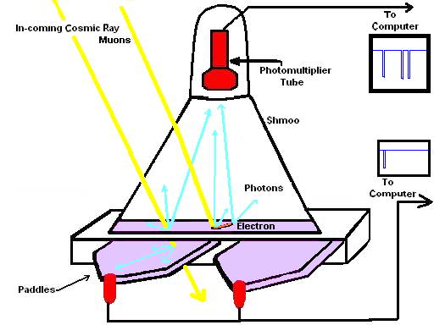
Signal from through-going muon
Signal from stopped muon and Michel electron
Figure 2

Data Collection and Analysis in Excel

The Excel worksheet muon_halflife.xls contains all the analysis structures needed to record a set of individual muon decay times and use them to find the half-life t_{1/2} of the muon. Most of the worksheet is locked to prevent students from accidentally changing formulas or graphs, but you can still select any cell and view the Excel formulas used to calculate results throughout the worksheet. If you wish to unlock the worksheet, you may do so by going to Tools > Protection > Unprotect Sheet and using the password “chicos” when prompted. Be sure to save a copy of the unaltered worksheet before you do this.

Column A [Decay Times (ns)] is the only data column left unlocked in the default version of the worksheet. Students will enter individual muon decay times in this column, and they will automatically be incorporated into the analysis performed by the remainder of the worksheet. The decay times recorded in column A correspond to individual muons which arrive randomly at the CHICOS particle detectors and happen to decay inside our detector volume. The detection apparatus measures, and we record, the time between the arrival of a muon and the production of its decay-product (Michel) electron. Note that the decay times in column A must be entered in nanoseconds (1ns=10⁻⁹s, and 1000ns=1μs). Students should enter some (50-100) decay times by hand, studying the behavior of the rest of the Excel worksheet as these decay times are added to the data set. Students should also note the apparent randomness of the individual decay times they are entering in column A; does it seem obvious from a few measurements what the muon half-life is, or even that there is a characteristic decay time scale? After some values have been entered by hand and discussed in this way, a much larger data set may be acquired automatically and imported into Column A all at once. The worksheet is set up to process up to 10,000 entries in Column A.

In Columns B through D, the decay times are histogrammed into preset time bins of 250-ns width (bins defined in Column B). Cell D2 contains the number of recorded muons which lasted less than 500ns, cell D3 contains the number of muons which lasted between 500ns and 750ns, and so on. Finally, cell D36 contains the number of muons which took more than 9000ns to decay. Note that 1000ns = 1 μs, and Column C simply lists all the time bins from Column B, but in units of μs.

Column E [N(number of muons remaining)] converts the information from Column D into a list of the number of muons remaining (not yet decayed) at the end of each time bin. To do this, we simply count the total number of muons recorded in the whole data set (the number of entries in Column A), and progressively subtract off the number which decay during each new time bin (the quantities in Column D’s histogram). Column E is the quantity N(t) from our earlier discussion of half-life. A graph of N(t) vs. Time is shown on the worksheet, but it is not used directly in further calculations.

In Column F we calculate log(N), so that we can graph log(N) vs. Time as discussed in the background lessons. This graph is shown on the worksheet. Both graphs include vertical error bars representing our uncertainty in the value of N (or log(N)). These error bars are given in Columns G and H. The uncertainty in N is taken to be the square root of N; this is the accepted uncertainty in a situation where we are counting a finite number of objects in order to estimate the average rate of occurrence of such objects. The uncertainty in log(N) is determined from the uncertainty in N using simple calculus, but we will not cover that process in detail here.

The graph of log(N) vs. Time also shows a straight line representing the best fit to the data (with its error bars). This best fit line is technically known as a chi-squared fit or weighted least-squares fit to the data and error bars shown on the graph. The graph displays the equation of the best fit line, so you can read off the slope and y-intercept values. At the top of columns K and L, we list the slope and y-intercept, along with the calculated uncertainties for the slope and y-intercept. After all, assuming the points do not absolutely perfectly fit the line, there will be a range of slopes which result in a reasonable fit to the data set.

In cell J7, we calculate the muon half-life from the slope of the fit line. This formula was derived in the preparatory lessons. In cell J9, we have calculated an uncertainty for the half-life, based on the reported uncertainty in the slope of our fit line. The exact formula for this uncertainty is derived using calculus, and we will not discuss the formula further here. However, it is important to understand that (a) our measurement of t_{1/2} has an uncertainty, which (b) is based on the uncertainty in the slope of our fit line, which (c) is based on the fact that our data are not perfectly smooth and linear and do not perfectly fall along a single line.

Cell J12 lists the total number of muon decay times recorded (the total number of entries made in Column A). Cell J15 lists the total number used to create our graph. Note that decay times less than 500ns or more than 8000ns are not included in the graph because of the range chosen for the graph. The information in cells J12 and J15 may be useful to students as they contemplate the number of decays necessary to obtain a smooth graph and an accurate/precise determination of the muon half-life.

[Note: The weighted least squares fit to the data is calculated from the data and error bars in a set of algebra manipulations on Sheet 2 of the Excel workbook. The formulas for fitting a straight line to data + error bars are derived in many statistic and mathematics references, and we need not discuss them here. We will only note, for those interested, the definition of the weighted least squares fit line:
For data points x_{i} and y_{i}±σ_{I}, the weighted least squares line mx+b has values of m and b which minimize
Σ
i=1
n
(y_{i} – (mx_{i} + b))²
σ_{ι}²

This line is similar to the built-in Excel “trendline” feature, but the Excel trendline assumes equal uncertainties σ_{i} for all data points. When fitting a weighted data set to a straight line, the optimal line can be found via simple algebra. Fitting a weighted data set to any other functional form (quadratic, exponential, trig function, etc.) is mathematically considerably more involved. This is one reason we prefer to calculate and plot log(N) rather than N in to find a half-life, as in this activity.]
APPENDIX: Sources for Illustrations (non-CHICOS sources listed)

Round Cloud Chamber Photo
http://www.physics.ubc.ca/~outreach/phys420/p420_99/flora/howdetect.html
which cites http://freeweb.pdq.net/headstrong/cloud.htm (link does not work as of June 2006)

Dead Sea Scrolls
http://www.ibiblio.org/expo/deadsea.scrolls.exhibit/intro.html

Bones
http://www.bbc.co.uk/history/archaeology/carbondating_1.shtml

E=mc²
http://www-unix.oit.umass.edu/~uril/phil382/E=mc2(small).JPG

Han Dynasty cloth
http://www.textile-art.com/c01/19335.html

Anderson and e+/e- Photos
http://livefromcern.web.cern.ch/livefromcern/antimatter/history/AM-history01-a.html
(images copyright Caltech)

Pennies Photo
http://mathdl.maa.org/mathDL/4/?pa=content&sa=viewDocument&nodeId=448&bodyId=515

Scintillator
http://www.lbl.gov/abc/cosmic/parts.html

PMT
http://www.ast.leeds.ac.uk/haverah/detector.shtml

